WEEK-4

Spring-Rest Hands-on

**Exercise-1: Create a Spring Web Project using Maven**

**SpringApplication.java**:

package com.cognizant.spring_learn;

import org.slf4j.Logger;

import org.slf4j.LoggerFactory;

import org.springframework.boot.SpringApplication;

import org.springframework.boot.autoconfigure.SpringBootApplication;

@SpringBootApplication

public class SpringLearnApplication {

private static final Logger LOGGER = LoggerFactory.getLogger(SpringLearnApplication.class);

public static void main(String[] args) {

LOGGER.info("START - SpringLearnApplication main()");

SpringApplication.run(SpringLearnApplication.class, args);

LOGGER.info("END - SpringLearnApplication main()");

}

}

**pom.xml:**

<project xmlns="http://maven.apache.org/POM/4.0.0" ...>

<modelVersion>4.0.0</modelVersion>

<groupId>com.cognizant</groupId>

<artifactId>spring-learn</artifactId>

<version>0.0.1-SNAPSHOT</version>

<name>spring-learn</name>

<dependencies>

<dependency>

<groupId>org.springframework.boot</groupId>

<artifactId>spring-boot-starter-web</artifactId>

</dependency>

<dependency>

<groupId>org.springframework.boot</groupId>

<artifactId>spring-boot-devtools</artifactId>

<scope>runtime</scope>

</dependency>

<dependency>

<groupId>org.springframework.boot</groupId>

<artifactId>spring-boot-starter-test</artifactId>

<scope>test</scope>

</dependency>

</dependencies>

<build>

<plugins>

<plugin>

<groupId>org.springframework.boot</groupId>

<artifactId>spring-boot-maven-plugin</artifactId>

</plugin>

</plugins>

</build>

</project>

**OUTPUT:**

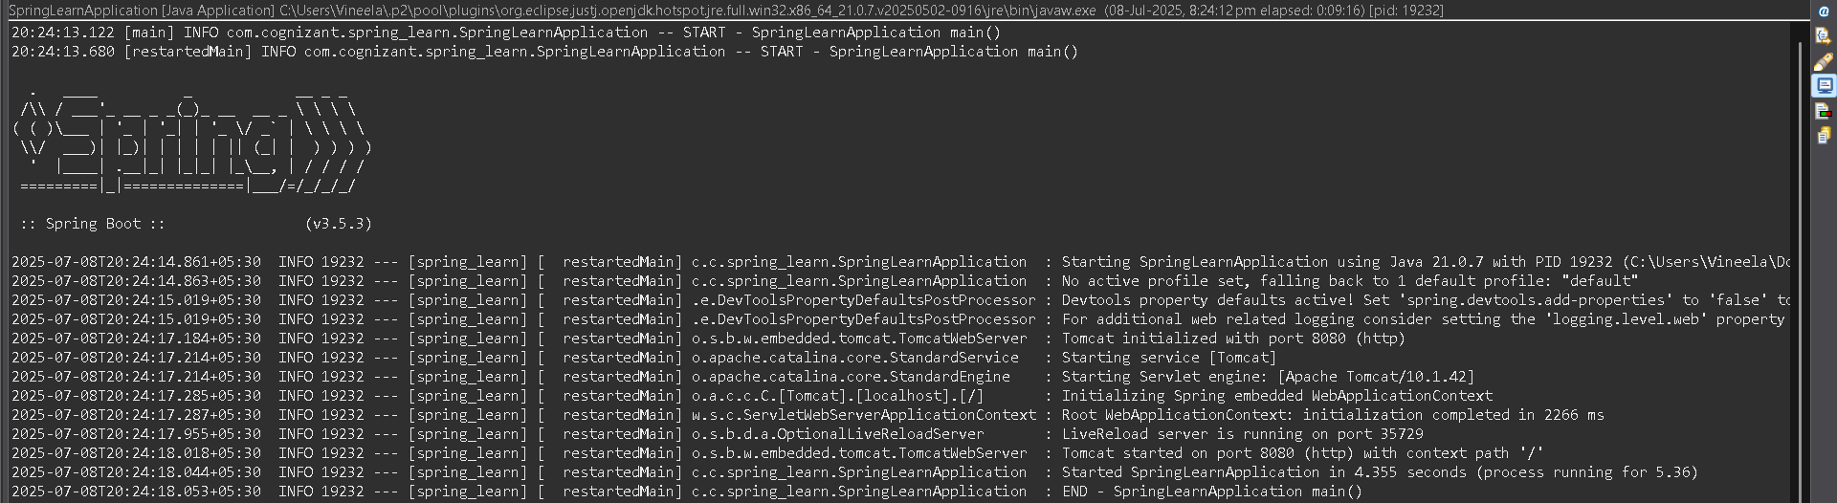

**Exercise-2: Spring Core – Load SimpleDateFormat from Spring Configuration XML**

**Src/main/resources/date-format.xml:**

<?xml version="1.0" encoding="UTF-8"?>

<beans xmlns="http://www.springframework.org/schema/beans"

xmlns:xsi="http://www.w3.org/2001/XMLSchema-instance"

xsi:schemaLocation="

http://www.springframework.org/schema/beans

https://www.springframework.org/schema/beans/spring-beans.xsd">

<bean id="dateFormat" class="java.text.SimpleDateFormat">

<constructor-arg value="dd/MM/yyyy" />

</bean>

</beans>

**src/main/java/com/cognizant/spring_learn/SpringLearnApplication.java:**

package com.cognizant.spring_learn;

import org.slf4j.Logger;

import org.slf4j.LoggerFactory;

import org.springframework.context.ApplicationContext;

import org.springframework.context.support.ClassPathXmlApplicationContext;

import java.text.SimpleDateFormat;

import java.util.Date;

public class SpringLearnApplication {

private static final Logger LOGGER = LoggerFactory.getLogger(SpringLearnApplication.class);

public static void main(String[] args) {

LOGGER.info("START - SpringLearnApplication main()");

SpringLearnApplication.displayDate();

LOGGER.info("END - SpringLearnApplication main()");

}

public static void displayDate() {

ApplicationContext context = new ClassPathXmlApplicationContext("date-format.xml");

SimpleDateFormat format = context.getBean("dateFormat", SimpleDateFormat.class);

try {

Date parsedDate = format.parse("31/12/2018");

System.out.println("Parsed Date: " + parsedDate);

} catch (Exception e) {

e.printStackTrace();

}

}

}

OUTPUT:

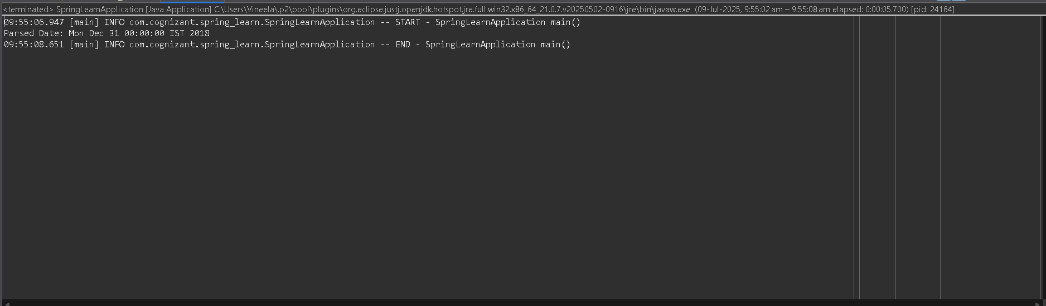

**Exercise-3: Spring Core - Incorporate Logging**

**application.properties:**

server.port=9090

spring.application.name=spring_learn

logging.level.org.springframework=info

logging.level.com.cognizant.spring_learn=debug

logging.pattern.console=%d{yyMMdd}|%d{HH:mm:ss.SSS}|%-20.20thread|%5p|%-25.25logger{25}|%25M|%m%n

logback.xml:

<configuration>

<appender name="CONSOLE" class="ch.qos.logback.core.ConsoleAppender">

<encoder>

<pattern>%d{yyMMdd}|%d{HH:mm:ss.SSS}|%-20.20thread|%5p|%-25.25logger{25}|%25M|%m%n</pattern>

</encoder>

</appender>

<logger name="com.cognizant.spring_learn" level="DEBUG" />

<root level="INFO">

<appender-ref ref="CONSOLE"/>

</root>

</configuration>

Date-format.xml:

<?xml version="1.0" encoding="UTF-8"?>

<beans xmlns="http://www.springframework.org/schema/beans"

xmlns:xsi="http://www.w3.org/2001/XMLSchema-instance"

xsi:schemaLocation="

http://www.springframework.org/schema/beans

https://www.springframework.org/schema/beans/spring-beans.xsd">

<bean id="dateFormat" class="java.text.SimpleDateFormat">

<constructor-arg value="dd/MM/yyyy"/>

</bean>

</beans>

**SpringLearnApplication:**

import org.slf4j.Logger;

import org.slf4j.LoggerFactory;

import org.springframework.context.ApplicationContext;

import org.springframework.context.support.ClassPathXmlApplicationContext;

import java.text.SimpleDateFormat;

import java.util.Date;

public class SpringLearnApplication {

private static final Logger LOGGER = LoggerFactory.getLogger(SpringLearnApplication.class);

public static void main(String[] args) {

LOGGER.info("START - SpringLearnApplication main()");

displayDate();

LOGGER.info("END - SpringLearnApplication main()");

}

public static void displayDate() {

LOGGER.info("START - displayDate()");

ApplicationContext context = new ClassPathXmlApplicationContext("date-format.xml");

SimpleDateFormat format = context.getBean("dateFormat", SimpleDateFormat.class);

try {

Date date = format.parse("31/12/2018");

LOGGER.debug("Parsed Date: {}", date); // This should now be visible

} catch (Exception e) {

LOGGER.error("Error parsing date", e);

}

LOGGER.info("END - displayDate()");

}

}

OUTPUT:

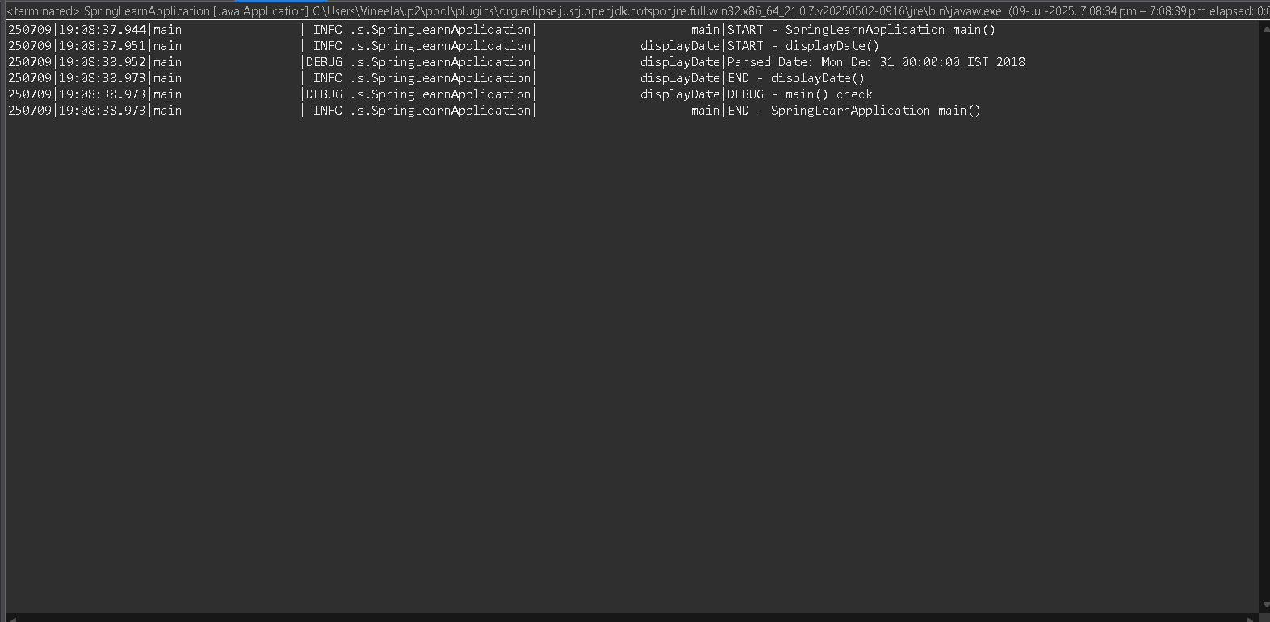

**Exercise-4: Spring Core – Load Country from Spring Configuration XML**

**src/main/java/com/cognizant/spring_learn/Country.java:**

package com.cognizant.spring_learn;

import org.slf4j.Logger;

import org.slf4j.LoggerFactory;

public class Country {

private static final Logger LOGGER = LoggerFactory.getLogger(Country.class);

private String code;

private String name;

public Country() {

LOGGER.debug("Inside Country Constructor.");

}

public String getCode() {

LOGGER.debug("Inside getCode()");

return code;

}

public void setCode(String code) {

LOGGER.debug("Inside setCode()");

this.code = code;

}

public String getName() {

LOGGER.debug("Inside getName()");

return name;

}

public void setName(String name) {

LOGGER.debug("Inside setName()");

this.name = name;

}

@Override

public String toString() {

return "Country [code=" + code + ", name=" + name + "]";

}

}

**src/main/resources/country.xml:**

<?xml version="1.0" encoding="UTF-8"?>

<beans xmlns="http://www.springframework.org/schema/beans"

xmlns:xsi="http://www.w3.org/2001/XMLSchema-instance"

xsi:schemaLocation="http://www.springframework.org/schema/beans

https://www.springframework.org/schema/beans/spring-beans.xsd">

<bean id="country" class="com.cognizant.spring_learn.Country">

<property name="code" value="IN" />

<property name="name" value="India" />

</bean>

</beans>

**SpringLearnApplication:**

import org.slf4j.Logger;

import org.slf4j.LoggerFactory;

import org.springframework.context.ApplicationContext;

import org.springframework.context.support.ClassPathXmlApplicationContext;

public class SpringLearnApplication {

private static final Logger LOGGER = LoggerFactory.getLogger(SpringLearnApplication.class);

public static void main(String[] args) {

LOGGER.info("START - SpringLearnApplication main()");

displayDate();

displayCountry();

LOGGER.info("END - SpringLearnApplication main()");

}

public static void displayCountry() {

LOGGER.info("START - displayCountry()");

ApplicationContext context = new ClassPathXmlApplicationContext("country.xml");

Country country = context.getBean("country", Country.class);

LOGGER.debug("Country : {}", country.toString());

LOGGER.info("END - displayCountry()");

}

}

**OUTPUT:**

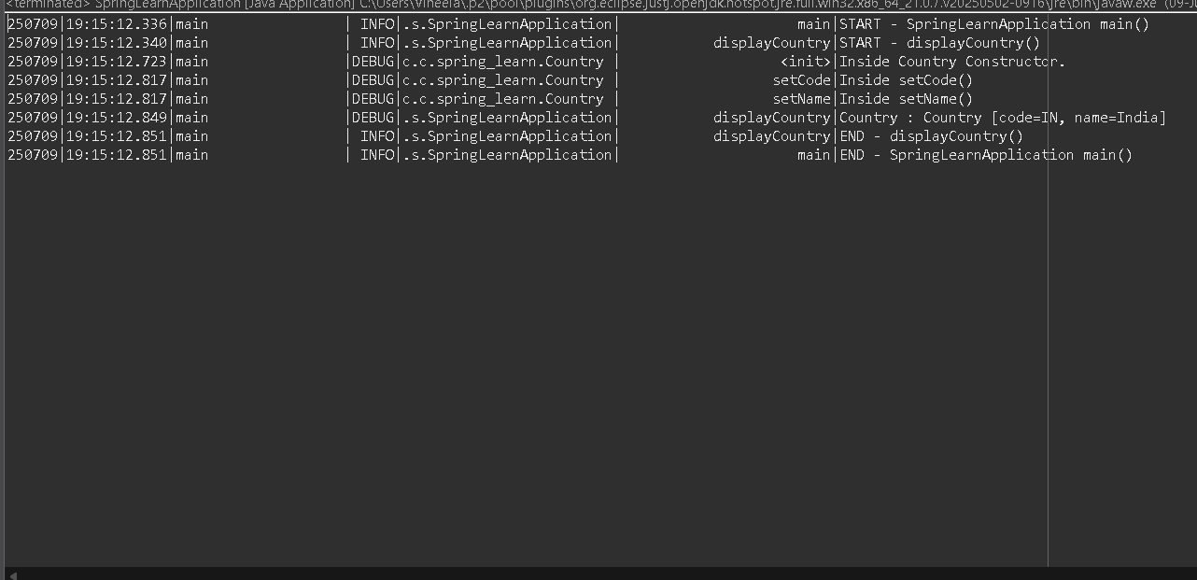

**Exercise-5: Spring Core – Demonstration of Singleton Scope and Prototype Scope**

**src/main/resources/country.xml:**

<?xml version="1.0" encoding="UTF-8"?>

<beans xmlns="http://www.springframework.org/schema/beans"

xmlns:xsi="http://www.w3.org/2001/XMLSchema-instance"

xsi:schemaLocation="http://www.springframework.org/schema/beans

https://www.springframework.org/schema/beans/spring-beans.xsd">

<bean id="country" class="com.cognizant.spring_learn.Country" scope="prototype">

<property name="code" value="IN" />

<property name="name" value="India" />

</bean>

</beans>

**SpringLearnApplication.java:**

import org.slf4j.Logger;

import org.slf4j.LoggerFactory;

import org.springframework.context.ApplicationContext;

import org.springframework.context.support.ClassPathXmlApplicationContext;

public class SpringLearnApplication {

private static final Logger LOGGER = LoggerFactory.getLogger(SpringLearnApplication.class);

public static void main(String[] args) {

LOGGER.info("START - SpringLearnApplication main()");

displayDate();

displayCountry();

LOGGER.info("END - SpringLearnApplication main()");

}

public static void displayCountry() {

LOGGER.info("START - displayCountry()");

ApplicationContext context = new ClassPathXmlApplicationContext("country.xml");

Country country = context.getBean("country", Country.class);

Country anotherCountry = context.getBean("country", Country.class);

LOGGER.debug("Country : {}", country);

LOGGER.debug("Another Country : {}", anotherCountry);

LOGGER.debug("Same instance? {}", country == anotherCountry); // true if singleton

LOGGER.info("END - displayCountry()");

}

}

**OUTPUT:**

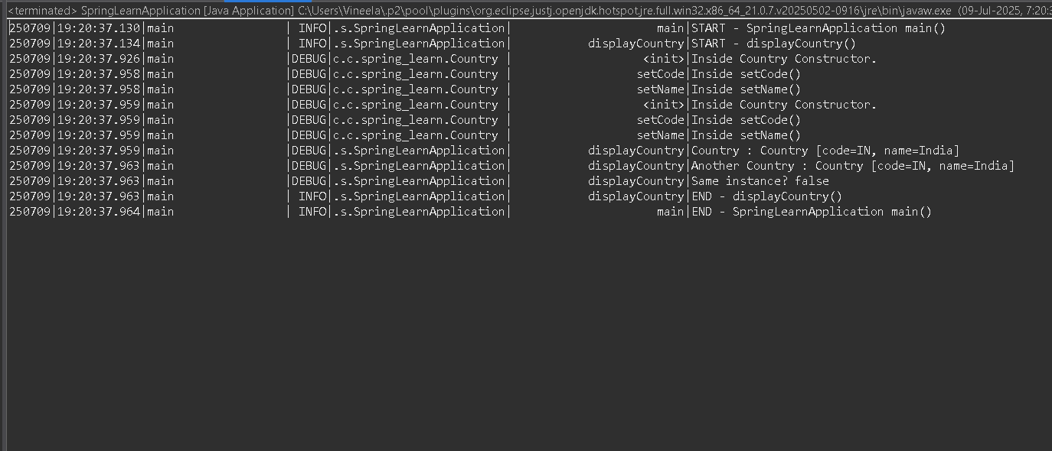

**Excercise-6: Spring Core – Load list of countries from Spring Configuration XML**

**src/main/resources/country.xml:**

<?xml version="1.0" encoding="UTF-8"?>

<beans xmlns="http://www.springframework.org/schema/beans"

xmlns:xsi="http://www.w3.org/2001/XMLSchema-instance"

xsi:schemaLocation="http://www.springframework.org/schema/beans

https://www.springframework.org/schema/beans/spring-beans.xsd">

<bean id="in" class="com.cognizant.spring_learn.Country">

<property name="code" value="IN"/>

<property name="name" value="India"/>

</bean>

<bean id="us" class="com.cognizant.spring_learn.Country">

<property name="code" value="US"/>

<property name="name" value="United States"/>

</bean>

<bean id="de" class="com.cognizant.spring_learn.Country">

<property name="code" value="DE"/>

<property name="name" value="Germany"/>

</bean>

<bean id="jp" class="com.cognizant.spring_learn.Country">

<property name="code" value="JP"/>

<property name="name" value="Japan"/>

</bean>

<bean id="countryList" class="java.util.ArrayList">

<constructor-arg>

<list>

<ref bean="in"/>

<ref bean="us"/>

<ref bean="de"/>

<ref bean="jp"/>

</list>

</constructor-arg>

</bean>

</beans>

**SpringLearnApplication.java:**

import org.slf4j.Logger;

import org.slf4j.LoggerFactory;

import org.springframework.context.ApplicationContext;

import org.springframework.context.support.ClassPathXmlApplicationContext;

import java.util.ArrayList;

import java.util.List;

public class SpringLearnApplication {

private static final Logger LOGGER = LoggerFactory.getLogger(SpringLearnApplication.class);

public static void main(String[] args) {

LOGGER.info("START - SpringLearnApplication main()");

displayDate();

displayCountry();

LOGGER.info("END - SpringLearnApplication main()");

}

public static void displayCountry() {

LOGGER.info("START - displayCountry()");

ApplicationContext context = new ClassPathXmlApplicationContext("country.xml");

Country country = context.getBean("country", Country.class);

Country anotherCountry = context.getBean("country", Country.class);

LOGGER.debug("Country : {}", country);

LOGGER.debug("Another Country : {}", anotherCountry);

LOGGER.debug("Same instance? {}", country == anotherCountry); // true if singleton

LOGGER.info("END - displayCountry()");

}

public static void displayCountries() {

LOGGER.info("START - displayCountries()");

ApplicationContext context = new ClassPathXmlApplicationContext("country.xml");

List<Country> countryList = (List<Country>) context.getBean("countryList");

for (Country c : countryList) {

LOGGER.debug("Country: {}", c);

}

LOGGER.info("END - displayCountries()");

}

}

**OUTPUT:**

